|  |
| --- |
| 新东方在线英语学习 |
| 新概念 1 册 |
| Lesson115-116 |



扫一扫。更多有趣的英语资讯。

**Lesson 115 单词讲解**1.anyone: pron.(用于疑问句，否定式)任何人

2.knock: v.打

knock at

knock at the door

3.everything: pron.一切事物ai v rui

Everything is fine. 一切都很挺好。

1. quiet: adj. 宁 静 的 ， 安 静 的 kuai er te
2. Everything is quite. 一切都很安静。
3. impossible: adj.不可能的im+ possible

impolite: 不礼貌的pu lai te

imperfect: 不完美的

immature: 不成熟的ma tui er

immoral: 没有道德的mao rou

1. invite: v.邀请invite sb. to do invite sb. to + n.

他邀请我吃了一顿饭。

He invited me to have a meal. He invited me to a meal.

1. anything: pron.任何东西8.nothing: pron.什么也没有9.lemonade: n. 柠檬水

lai mei nei d

1. 10.joke: v.开玩笑zhou ke

She is only joking. 她只是开个玩笑。

joke n. 笑话讲 笑 话 ： make a joke

# Lesson 115 课文讲解

1. Knock, knock！
2. 家里有人吗？

Is there anyone at home?

Isn’t there anyone at home?

1. Look through the window.

look at… look into… look out of…

1. Can you see anything? Nothing at all.
2. Everyone is in the garden.

大家都在花园里。

1. It’s nice and … out here.

外面这…

里面这：in here

1. Come and have something to drink. have something to…

吃点东西：

have something to eat

买到东西：

have something to buy

读点东西：

have something to read

1. There is none left.

none: 什么也没

There is none.

none + of + n.\pron.

None of the students 学生中没有人… None of us 我们当中没有人…

None of them 他们当中没有人…

8. There is none left.



left: leave- left- left

left- adj.

none left: 剩下的什么都没有了

nothing left

nobody left

不定代词

# Lesson 115 语法讲解

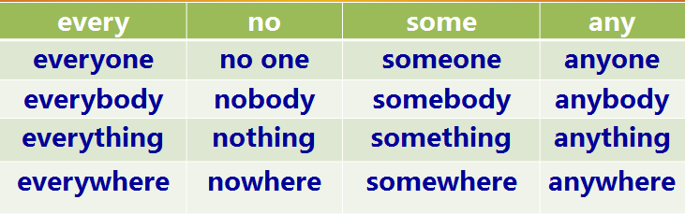

1. everyone\everybody\everything\everywhere

整体

everyone\ everybody: 大家everything: 一切everywhere: 到处

Hi, everyone. 大家好！

Everything is quiet. 一切都很安静。

A humorous person is accepted everywhere.

幽默的人到处都受欢迎。

1. no one\nobody\nothing\nowhere no one\ nobody: 没有人
2. nothing: 什么都没有
3. nowhere: 没有一个地方

There is no one at home. 家里一个人都没有。

I have nothing to do. 我没事可做。

She has nowhere to go. 她无处可去。

1. some: 一些

some: 某一

someone\ somebody: 某人something: 某事somewhere: 某地

# 肯定句

There is someone at home. 家里有人。

I have something to do. 我有事要做。

She went somewhere. 她去了什么地方。

1. any: 一些

any: 任一

anyone\ anybody: 任何人anything: 任何事anywhere: 任何地方

# 否定、疑问句

Is there anyone at home? 家里有人吗？

I don’t have anything to do. 我没事可做。

She didn’t go anywhere. 她哪都没去。

1. any& no 的转化

nothing= not anything

I did nothing yesterday.=I didn’t do anything. nobody= not anybody

I met nobody.=I didn’t meet anybody. nowhere= not anywhere

I went nowhere.=I didn’t go anywhere.

6.

# 做主语- 看作单数！

大家都知道这事。Everybody knows it. 一切都很顺利。Everything is fine. 那有人吗？

Is there anyone there?

# Lesson 116 单词句型讲解

1. asleep: adj. 睡觉、睡着（用作表语）

He is asleep. awake: 醒着的 I am awake. alive:活着的

She is alive. 她还活着。

1. glasses: n. 眼镜

glass, 玻璃、玻璃杯

a pair of glasses

# Lesson 115&116 知识拓展



**Impossible is nothing.**

**Anything is possible**

* Everything has its beauty, but not everyone sees it.

万物皆美，只是缺少发现美得眼睛。

* She wants her son to become somebody.

她希望自己的儿子会成为个人物。

* 没有什么能够阻挡我对自由的向往。

Nothing could ever stand between you and the free land .